Openwrt firmware module upgrade method
The modules of openwrt can use the following two firmware upgrade methods when the firmware is delivered from the factory

A. Upgrade firmware through network interface under uboot
Upgrade network interface: one of P1~P4 network interfaces needs to be used, and P0 interface cannot be upgraded
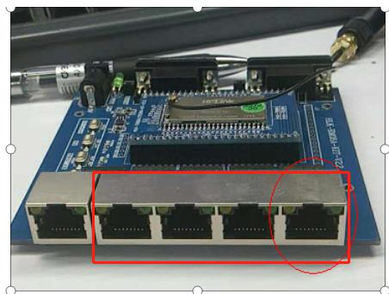

PC uses serial port to connect to HLK7688 debugging serial port
Serial port setting as:
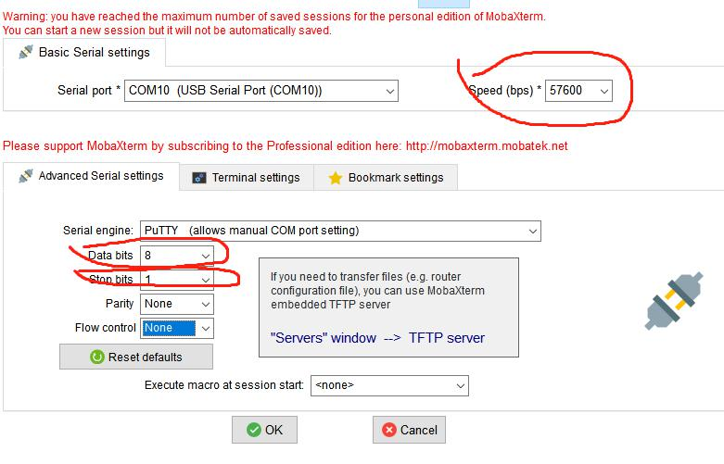
When powering on and starting, it will count down. At this time, press 2 on the keyboard to upgrade the firmware through TFTP
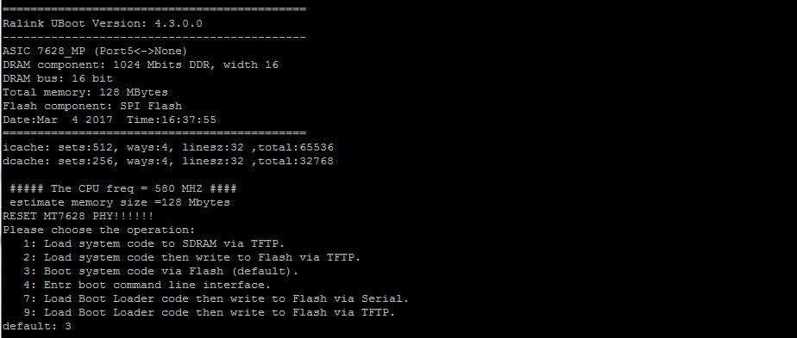
Prompt whether to erase Linux in Flash Type: y
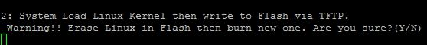

Specify parameters for TFTP:
Input device IP: device IP (board IP)
Input server IP: computer IP (set on PC network card)
Note: The two IPs must be in the same network segment, and the IPs cannot be the same
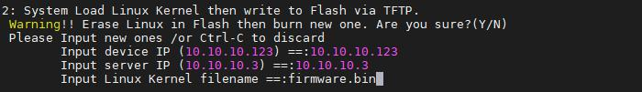
As shown in the figure above, change the IP address of the computer to 10.10.10.3
Fill in the firmware name to be upgraded: xxx.bin
Open TFTP on your computer
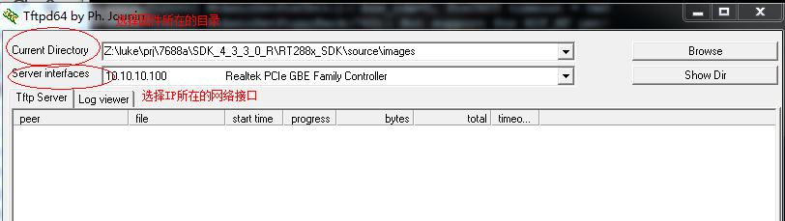
The default upgrade network ports for equipment shipment are P1~P4 ports. If Hailingke's backplane is used, there are five network ports in the backplane, and the separated network port is P0 port

Note: If the customer's board only leads out the P0 port, the default UBOOT cannot be upgraded through the network port

If promoted 
Please check the IP address of the PC and whether the network port is plugged correctly

- Use web page upgrade
Open Web Page:
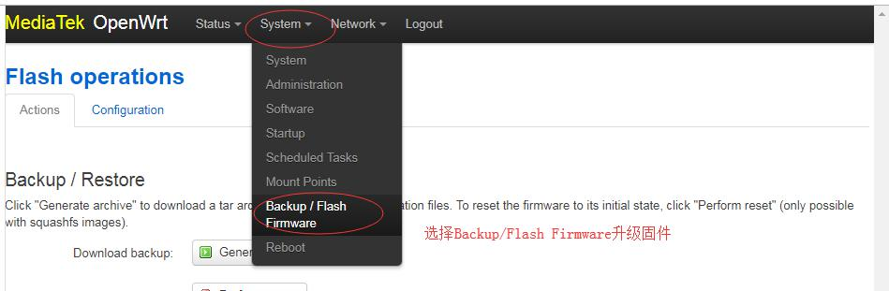Enter the firmware upgrade page: select the firmware, and click Flash Image
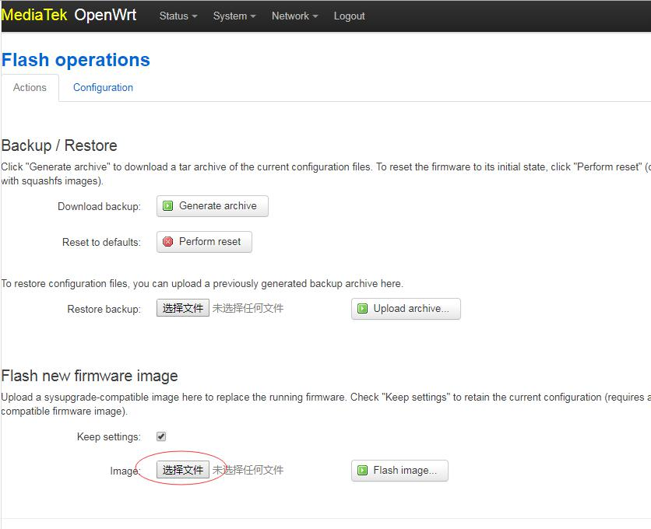After checking the information, click Process to upgrade the firmware
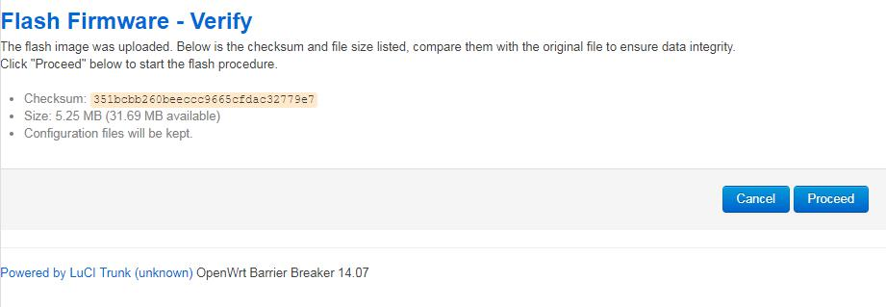
Upgrade uboot
Uboot Upgrade uboot
The PC needs to use the serial port to connect to the HLK7688 debugging serial port
Serial port setting:
When powering on and starting, it will count down. At this time, you can press 9 on the keyboard to upgrade uboot through TFTP
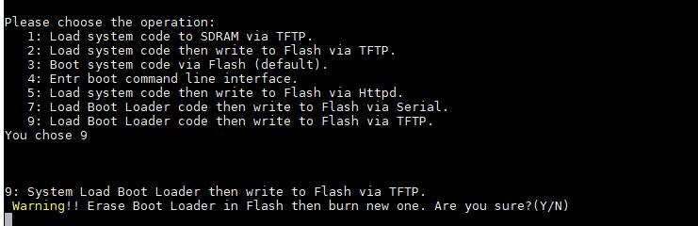
Press Y to confirm the upgrade of uboot
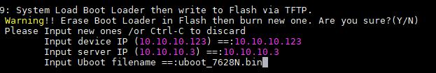
Input device IP module's own IP
Input server IP server IP (TFTP server) IP on PC
Input uboot filename File name of the uoot on the tftp server

